CSA1413
COMPILER DESIGN
Name: Haresh Kumar N L
Reg No: 192425009
Construction and Evaluation of Annotated Parse Tree

Aim:
To write a C program to construct an annotated parse tree for the given grammar and evaluate the value of an arithmetic expression.
Algorithm:
- Start the program.
- Define a structure to represent parse tree nodes with node name, value, and child pointers.
- Create a function to allocate and initialize new tree nodes.
- Implement parseT() to identify numeric values and construct T and num nodes.
- Implement parseE() to parse arithmetic expressions using the productions E → E + T and E → T.
- Calculate the expression value by adding the values of the left and right subtrees.
- Display the annotated parse tree with node names and their evaluated values.
- Print the final evaluated result.
- Stop the program.

Pseudocode:
BEGIN
DEFINE Node structure
name
value
left pointer
right pointer
END DEFINE
FUNCTION createNode(name, value, left, right)
Allocate memory for a new node
Assign name and value
Assign left and right children
RETURN node
END FUNCTION
FUNCTION parseT(input)
Read numeric value
Create num node
Create T node with the numeric value
RETURN T node
END FUNCTION
FUNCTION parseE(input)
left = parseT(input)
WHILE next character is '+'
Read '+'
right = parseT(input)
result = left.value + right.value
left = createNode(E, result, left, right)
END WHILE
RETURN left
END FUNCTION
READ arithmetic expression
root = parseE(expression)
DISPLAY annotated parse tree
DISPLAY final evaluated value
END

Code:
#include <stdio.h>
#include <stdlib.h>
#include <ctype.h>
typedef struct Node
{
char name[10];
int val;
struct Node *left;
struct Node *right;
} Node;
Node* createNode(char *name, int val, Node *left, Node *right)
{
Node *n = (Node*)malloc(sizeof(Node));
if (n == NULL)
{
printf("Memory allocation failed!\n");
exit(1);
}
snprintf(n->name, sizeof(n->name), "%s", name);
n->val = val;
n->left = left;
n->right = right;
return n;
}
Node* parseT(char **s)
{
int num = 0;
while (isspace((unsigned char)**s))
{
(*s)++;
}
if (!isdigit((unsigned char)**s))
{
printf("Invalid expression!\n");
exit(1);
}
while (isdigit((unsigned char)**s))
{
num = num * 10 + (**s - '0');
(*s)++;
}
Node *numNode = createNode("num", num, NULL, NULL);
return createNode("T", num, numNode, NULL);
}
Node* parseE(char **s)
{
Node *left = parseT(s);
while (1)
{
while (isspace((unsigned char)**s))
{
(*s)++;
}
if (**s != '+')
{
break;
}
(*s)++;
Node *right = parseT(s);
int result = left->val + right->val;
left = createNode("E", result, left, right);
}
return left;
}
void display(Node *root, int level)
{
if (root == NULL)
{
return;
}
for (int i = 0; i < level; i++)
{
printf(" ");
}
printf("%s = %d\n", root->name, root->val);
display(root->left, level + 1);
display(root->right, level + 1);
}
void freeTree(Node *root)
{
if (root == NULL)
{
return;
}
freeTree(root->left);
freeTree(root->right);
free(root);
}
int main()
{
char expression[100];
char *s;
Node *root;
printf("Enter arithmetic expression: ");

if (fgets(expression, sizeof(expression), stdin) == NULL)
{
printf("Input error!\n");
return 1;
}
s = expression;
root = parseE(&s);
while (isspace((unsigned char)*s))
{
s++;
}
if (*s != '\0')
{
printf("Invalid expression!\n");
freeTree(root);
return 1;
}
printf("\nAnnotated Parse Tree:\n");
display(root, 0);
printf("\nFinal Evaluated Value = %d\n", root->val);
freeTree(root);
return 0;
}

Input:
10 + 20

Output:
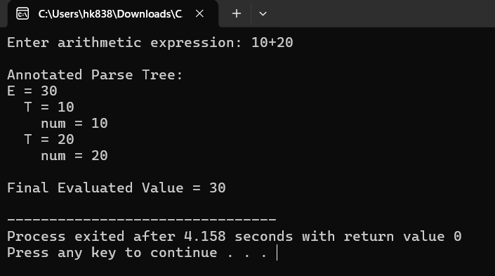
Result:
Thus, the C program to construct an annotated parse tree and evaluate the given arithmetic expression was executed successfully.

